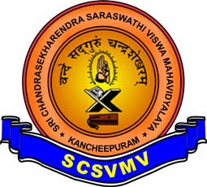 | Sri Chandrasekharendra Saraswathi Viswa MahaVidyalaya  (Accredited with ‘A’ Grade by NAAC)  [Deemed to be University Established Under Section 3 of UGC Act 1956]  Enathur, Kanchipuram – 631 561  Department of Computer Science & Applications
PARENT TEACHER MEETING REPORT
Date: 30 & 31 Oct, Th & Friday Venue: I BCA – A Class Room
Course | BCA | Year | I
Total Strength | 55 | Semester | I
Number of Boys | 41 | Number of Girls | 14

Minutes of PTA Meeting
The Purpose of the meet is to Notify and analyze the attendance, performance of the internal marks of the students with parents and to redress their grievances and to encourage and motivate them to enhance their skills.
ISSUES DISCUSSED
- Subject wise Performance of the students in the first & second internal
- Attendance percentage, shortage of attendance and its impacts
- Absentees and failure students in internal are instructed to complete the Assignment as soon as possible. Those who could not attend in person discussed over phone
- Class in charge discussed with students’ Parents whose att % was less than 50%
- Informed to attend the ongoing remedial classes from 2 to 5 before the exam.
Parents Met in Person:
S. No | Name
1. | J. Praveen kumar
2. | S. Ezhilarasan
3. | S. Ragavi
4 | Rajalaxmi R
5 | T. Kandeepan

